1. In the previous lecture, we learnt of how to pass data from a component down to another component (From parent to child).  
   <app-component> 🡸 **Parent Component**  
    <server-component [**name**]=”NightServer”>...</server-component>🡸 **Child Component where name is property of serverComponent with @input**  
   </app-component>
2. Now, we’ve to go the other direction. We want to pass something from child component to parent component. 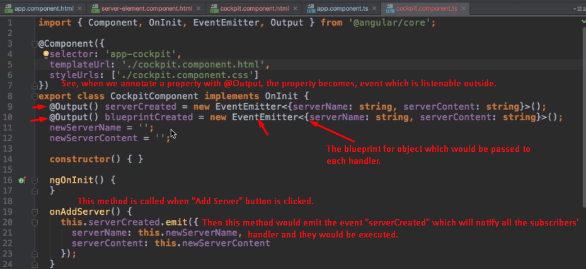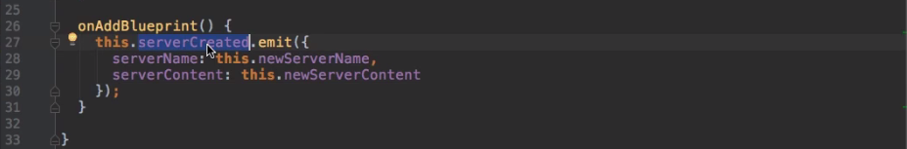 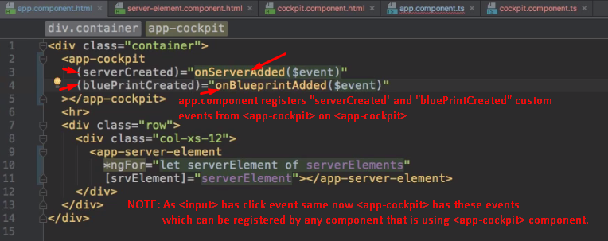
3. 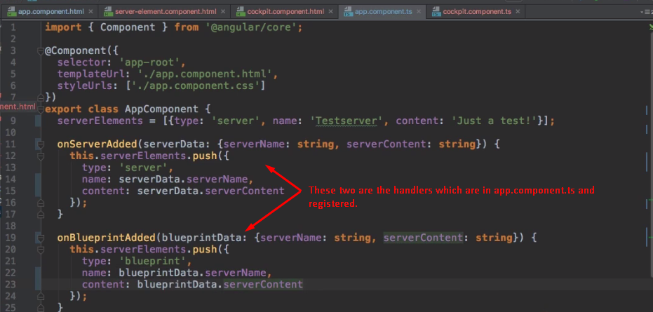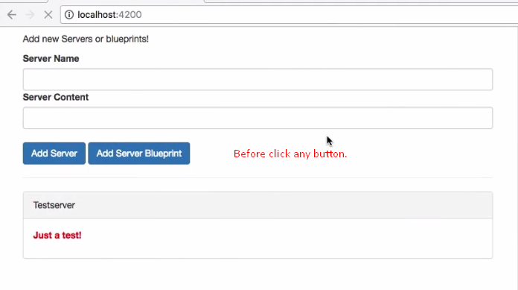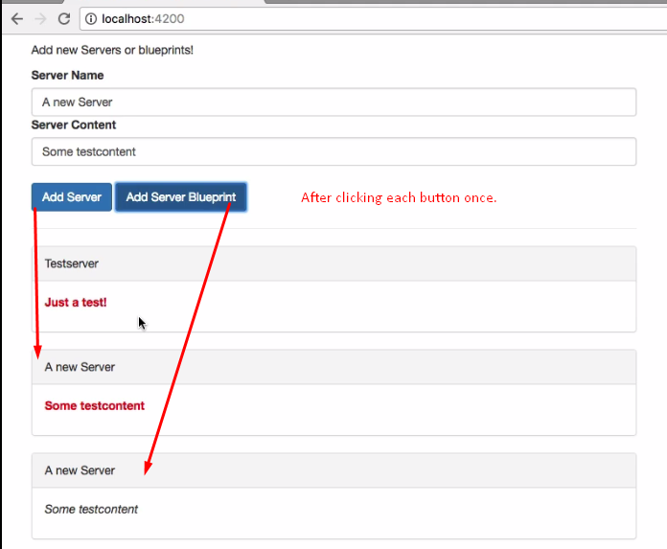
4. **@Input(“aliasOptinal”)**:
   1. To make a custom property bindable outside.
   2. To provide a custom property to outside.
   3. **Example**:  
      inside cockpit.component.ts🡺**@Input()** customProperty:string;  
      inside app.component.html using cockpit component 🡺 <app-cockpit [customProperty]=”expression”>
5. **@Output(“aliasOptional”)**:
   1. To make a custom event on custom component.
   2. To provide custom event on custom component to outside world.
   3. **Example**:  
      Inside cockpit.component.ts🡺**@Output** customEventForThisComponent = new EventEmitter<{id:string}>();  
      Inside app.component.html🡺<app-cockpit **(customEventForThisComponent)=”**handlerInAppCompoenntTsFile()”>